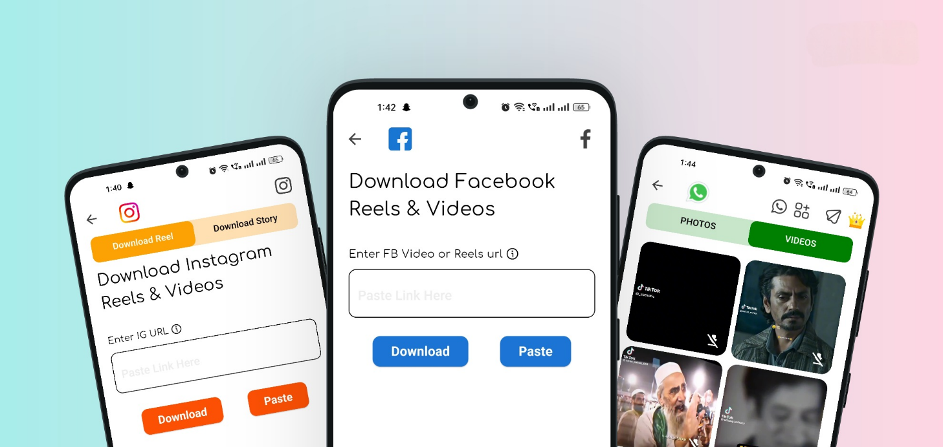

Meta Media

This Privacy Policy outlines how your data is collected, used, and shared when you use our application **Meta Media** for downloading Instagram, Facebook videos & Reels, and WhatsApp statuses. By using the App, you agree to the practices described in this policy. We are committed to protecting your privacy and ensuring transparency in the collection and handling of your personal information.

**Information Collection and Usage**

We collect personal information from you when you use the App, which may include:

* Information you provide directly, such as account information when you sign up or contact us.
* Automatically collected information, such as device data, app usage statistics, and other log data.

The information is used to:

* Provide, maintain, and improve the functionality of the App.
* Respond to your requests or inquiries.
* Ensure compliance with our terms and protect against misuse of the App.

**Log Data**

Whenever you use the App, we may collect data that your device sends, referred to as Log Data. This Log Data may include information such as your device's IP address, device name, operating system version, the configuration of the App, and the time and date of your use.

**Cookies**

Cookies are small files stored on your device that help us enhance your experience. The app does not use cookies directly. However, third-party services integrated into the app may use cookies to collect information and improve their services. You can manage your cookie preferences through your device’s settings.

**Service Providers**

We may employ third-party companies and individuals to assist us in providing the app, analyzing its performance, or improving its functionality. These third parties have access to your non-personal information only to perform these tasks on our behalf and are obligated not to disclose or use the data for any other purpose.

**Security**

We value your trust in providing information, and we strive to use commercially acceptable means to protect your data. However, please note that no method of transmission over the internet or method of electronic storage is 100% secure, and we cannot guarantee its absolute security.

**Links to Other Sites**

The app may contain links to external sites. If you click on a third-party link, you will be directed to that site. These external websites are not operated by us, and we strongly advise you to review the privacy policy of those websites. We have no control over and assume no responsibility for the content, privacy policies, or practices of third-party services.

**Children’s Privacy**

The app does not address anyone under the age of 13. We do not knowingly collect personally identifiable information from children under 13. If we discover that a child under 13 has provided us with personal information, we will immediately delete this from our servers. If you are a parent or guardian and believe your child has provided us with information, please contact us to ensure the necessary actions are taken.

**Changes to This Privacy Policy**

We may update our privacy policy from time to time to reflect changes in international internet regulations and our app’s functionalities. Any changes will be posted on this page, and the "Last Updated" date will be updated accordingly. You are advised to review this privacy policy periodically for any changes. Continued use of the app after modifications to the policy will constitute your acknowledgment and acceptance of the changes.

If you have any questions or concerns about this Privacy Policy, feel free to contact us.